**EXPERIMENT:**

1. Create a binary search tree by reading the inputs from file ’numbers.txt’. Display the inorder walk of the tree.

2. Compute the lowest common ancestor of binary search tree. Take the input from user after displaying the binary tree (in -order walk)

**PART 1:**

**PSEUDO CODE**

1)Create Structure

Data

Structure *left *right

2)function insert(x)

if(root = null)

Allocate memory to root

Store x in root data

Else

Node = root

while(node!=null)

If node data > x and node left is null

Allocate memory to node

Store x in node data

Break the loop

Else if node > x and node left is not null

Node = node->left

Else if node data < x and node right is null

Allocate memory to node

Store x in node data

Break the loop

Else if node>x and node right is not null

Node = node->right

3)Function inorder(struct *n)

If n is not null

inorder(n->left)

Print data of n

inorder(n->right)

4) main()

Open file in read mode

Read each number line by line and insert(x)

Call inorder(root)

Print inorder traversal

**INPUT**

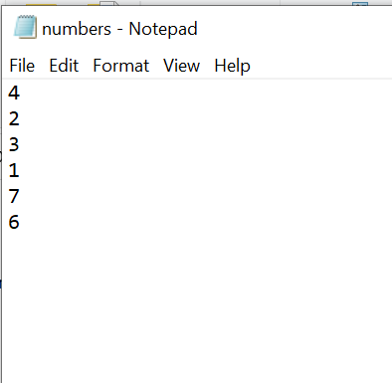

**OUTPUT**

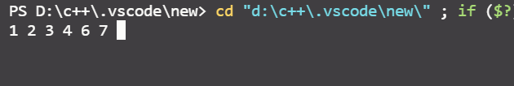

**PART 2:**

**PSEUDO CODE**

1)Create Structure

Data

Structure *left *right

2)function insert(x)

if(root = null)

Allocate memory to root

Store x in root data

Else

Node = root

while(node!=null)

If node data > x and node left is null

Allocate memory to node

Store x in node data

Break the loop

Else if node>x and node left is not null

Node = node->left

Else if node data < x and node right is null

Allocate memory to node

Store x in node data

Break the loop

Else if node>x and node right is not null

Node = node->right

3)Function inorder(struct *n)

If n is not null

inorder(n->left)

Print data of n

inorder(n->right)

4)function LowestCommonAncestor(struct *n,a,b)

If n is null return null

If data in n is greater than a and b return LowestCommonAncestor(n->left,a,b)

If data in n is less than a and b return LowestCommonAncestor(n->right,a,b)

Return root

5)main()

Input the total elements to be inserted in Tree

Insert the elements in the Tree

Do an inorder traversal of the Tree

Input two number of whivh we have to find LowestCommonAncestor

Use the LowestCommonAncestor function and print the output

**OUTPUT**

